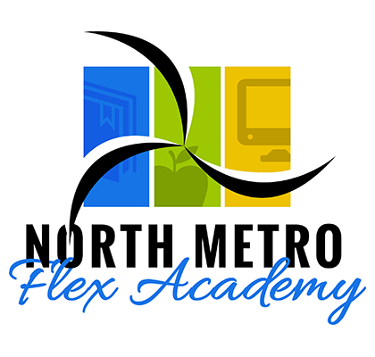
Hello North Metro Flex Academy Families,
Thank you so much for being a part of our school community! We have had quite the year pivoting throughout this pandemic! Thank you so much for supporting your students and our staff throughout all the learning models – Hybrid, Distance and now back to full In-Person (with some students still in distance learning).

Pivots in Leadership
Thank you also for being so supportive during this past month with the changes in our leadership and administrative staff. Our School Board voted to end our management contract with Accel Schools, which is why Ms. Privette and Mr. Caballero are no longer working at our school. (They are employees of Accel Schools.) Our school board is working diligently to restructure the management of our school in a more fiscally responsible way. (We know the timing seemed odd to occur in the middle of a school year.) Our school board had been working for months to reach better agreements and solutions for our school so that our authorizer, NEO, would re-authorize our school for the next 3 year cycle. NEO (Novation Educational opportunities) is our authorizer. Every public charter school needs to have an authorizer. We need them to authorize our public charter school so we are compliant with Minnesota Department of Education expectations. In order for NEO to re-authorize us, we needed to show proficiency in 4 areas. We needed to show proficiency in all areas that involved Academic, Finance, Operations and Culture/Climate. We were strong in 3 of the 4 areas. In order for us to be strong in all 4 areas moving forward, our board had to make the bold move to reduce the management fees with Accel Schools.
Debbie Kranz has been named the Principal (Interim) and Chelsea Smieja has been named the Operations Manager. Both, Debbie and Chelsea have been at this school since we opened and are working very hard to help transition smoothly.

Pivots in Technology
The School Board approved a Technology Contract with Jesse Shonfeld, who will be our IT Vendor for technology needs. Jesse has been at our school since we opened and is thoroughly skilled at adapting to all of our technology needs. Over spring break he re-imaged the computers needed for our Distance Learning students. We are still missing 67 devices! Those need to be returned next week. We will be sending out reminders to individual students if any devices are missing or damaged with costs included. It very important to send the devices back. In the event that we need to quarantine or move back to a different learning model, all the devices need to be re-imaged.

Pivots in Marketing
The School Board approved a marketing contract with Lisa and Dave Bonko, with Bonko Marketing services. They are a local husband and wife team who have worked with marketing needs of charter schools. They are helping our school to develop a marketing plan to retain and recruit students. The School Board also approved a contract with Centrum Web Designers, to help us build a new and improved web site. www.Northmetroflex.com will no longer be our website. Please watch for changes in the coming weeks!

Pivots in Art/Music
Due to the staffing needs of our school for the third trimester, we are needing to have our Art/music teacher, Maddie Anderson, only teach in person. She will be sending out an email with many links for all students to have access to her library of over 100 music and art videos. She will also send many other links especially for the students who are Distance Only students.

Pivots in School Messenger
Please see the flyer to add to the School Messenger services. Up to this point, you have been able to receive School messenger information through email. Starting in April, you will also be able to receive information through your phone/text messages.

Pivots in Parent Drop off and Pick Up
During hybrid we didn’t have many parents dropping off and picking up students. Of course, during Distance Learning we didn’t have any. Over the past month, as we have slowly brought most of our K-8th grade students back into the building full time, it has become obvious to us this week that we need to improve our drop off and pick up procedures!
Starting Monda,y March 22, during arrival and dismissal, only our busses will be allowed to enter from Margaret Street. Parents who are dropping of or picking up, need to enter and exit from Helen Street. Parents will be guided to park only in the parking lot. No cars will be allowed to park next to the building. Parents should stay in their cars. We will have staff to walk with students to and from the building to cars. We will be setting up cones so busses will not be crossing the walkways for our students being dropped off or picked up.

Thank you so much for your students. We are working hard to be SAFE, KIND and RESPONSIBLE.
Every morning I tell your students during the announcements…
”We love you, we like you, we are proud of you!”
Thank you for trusting us with your most precious people!
Mrs. Kranz
Principal (interim) (651-968-6428)

